20PW16

1.client

# -*- coding: utf-8 -*-

"""

Created on Fri Dec 24 15:16:34 2021

@author: 20pw16

"""

import socket

s = socket.socket()

host = socket.gethostname()

port = 65456

s.connect((host,port))

while True:

msg = input("Please enter a message to the server: ")

s.send(msg.encode())

recvd = s.recv(1024).decode()

if recvd.lower()=='bye':

print("Goodbye")

break

else:

print(f"Message from the server {recvd}")

continue

s.close()

1.server

# -*- coding: utf-8 -*-

"""

Created on Fri Dec 24 15:16:31 2021

@author: 20pw16

"""

import socket

s = socket.socket()

host = socket.gethostname()

port = 65456

s.bind((host,port))

s.listen(5)

while True:

c, addr = s.accept()

while True:

message = c.recv(1024).decode()

if message:

c.send(message.encode())

c.close()

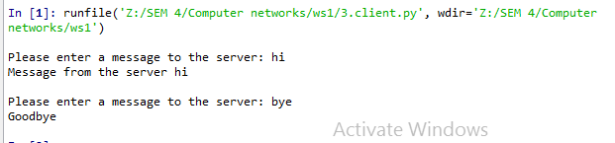

2.client

# -*- coding: utf-8 -*-

"""

Created on Fri Dec 24 14:58:17 2021

@author: 20pw16

"""

import socket

s = socket.socket()

host = socket.gethostname()

port = 65456

s.connect((host,port))

while True:

msg = input("Please enter a message to the server: ")

s.send(msg.encode())

recvd = s.recv(1024).decode()

print(recvd)

if recvd == "Goodbye":

break

s.close()

2.server

# -*- coding: utf-8 -*-

"""

Created on Fri Dec 24 14:58:08 2021

@author: 20pw16

"""

import socket

s = socket.socket()

host = socket.gethostname()

port = 65456

s.bind((host,port))

s.listen(5)

while True:

c, addr = s.accept()

while True:

message = c.recv(1024).decode()

if message.lower() == 'bye':

c.send("Goodbye".encode())

break

else:

c.send(message[::-1].encode())

c.close()

OUTPUT:

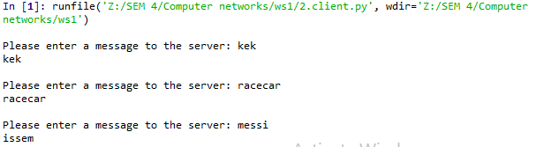

3.client

import socket

s = socket.socket()

host = socket.gethostname()

port = 65456

s.connect((host,port))

while True:

msg = input("Please enter a message to the server: ")

s.send(msg.encode())

recvd = s.recv(1024).decode()

print(f"Message from the server {recvd}")

ch=input("Do you want to continue?")

#s.send(ch.encode())

if ch.lower()=='n':

break

else:

continue

s.close()

3.server

# -*- coding: utf-8 -*-

"""

Created on Wed Dec 22 10:34:39 2021

@author: 20pw16

"""

import socket

s = socket.socket()

host = socket.gethostname()

port = 65456

s.bind((host,port))

s.listen(5)

while True:

c, addr = s.accept()

while True:

message = c.recv(1024).decode()

if message:

c.send(message.encode())

c.close()

#socket.accept() Accept a connection.The socket must be bound to an address and listening for connections.The return value is a pair (conn, address) where conn is a new socket object usable to send and receive data on the connection, and address is the address bound to the socket on the other end of the connection.

OUTPUT:

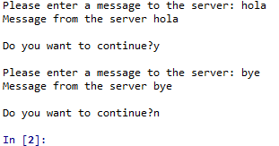

4.client

# -*- coding: utf-8 -*-

"""

Created on Fri Dec 24 15:17:40 2021

@author: 20pw16

"""

import socket

s = socket.socket()

host = socket.gethostname()

port = 65456

s.connect((host,port))

while True:

msg = input("Please enter a message to the server: ")

s.send(msg.encode())

recvd = s.recv(1024).decode()

print(f"Message from the server {recvd}")

ch=input("Do you want to continue?")

#s.send(ch.encode())

if ch.lower()=='n':

break

else:

continue

s.close()

4.server

# -*- coding: utf-8 -*-

"""

Created on Fri Dec 24 15:17:37 2021

@author: 20pw16

"""

import socket

s = socket.socket()

host = socket.gethostname()

port = 65456

s.bind((host,port))

s.listen(5)

while True:

c, addr = s.accept()

while True:

message = c.recv(1024).decode()

res = ''.join(format(ord(i), '08b') for i in message)

c.send(res.encode())

c.close()

OUTPUT:

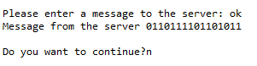

5.client

# -*- coding: utf-8 -*-

"""

Created on Fri Dec 24 15:30:37 2021

@author: 20pw16

"""

import socket

s = socket.socket()

host = socket.gethostname()

port = 65456

s.connect((host,port))

while True:

recvd = s.recv(1024).decode()

print(f"{recvd}")

break

s.close()

5.server

# -*- coding: utf-8 -*-

"""

Created on Fri Dec 24 15:30:35 2021

@author: 20pw16

"""

import socket

from datetime import datetime

today=datetime.today()

now=datetime.now()

current_time = now.strftime("%H:%M:%S")

d2 = today.strftime("%B %d, %Y")

s = socket.socket()

host = socket.gethostname()

port = 65456

s.bind((host,port))

s.listen(5)

while True:

c, addr = s.accept()

print(f"Got connection from {addr}")

while True:

c.send(f"Time i got from the server {d2} {current_time}".encode())

c.close()

OUTPUT:

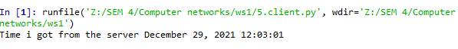

6.client

# -*- coding: utf-8 -*-

"""

Created on Fri Dec 24 15:50:26 2021

@author: 20pw16

"""

import socket

import pickle

s = socket.socket()

host = socket.gethostname()

port = 65456

mydict={'a':1}

message=pickle.dumps(mydict)

s.bind((host,port))

s.listen(5)

while True:

c, addr = s.accept()

print(f"Got connection from {addr}")

while True:

c.send(message)

c.close()

6.server

# -*- coding: utf-8 -*-

"""

Created on Fri Dec 24 15:50:27 2021

@author: 20pw16

"""

import socket

import pickle

s = socket.socket()

host = socket.gethostname()

port = 65456

s.connect((host,port))

while True:

recvd = s.recv(1024)

print(pickle.loads(recvd))

break

s.close()

OUTPUT:

